MicroTCAD

Version 1.0 – 07/09/2026

1.Overview
MicroTCAD is a Python based semiconductor device simulator built to simulate semiconductor devices in various conditions prior to fabrication. This project was started as a way for me to learn more about semiconductor physics and the numerical methods used to simulate them as well as how a semiconductor’s fundamental properties affect its real-world functionality.
Version 1 of this project focuses on Silicon, specifically for a pn junction diode. It consists of:
- 1D Poisson solver, that currently solves Poisson’s equation with Boltzmann carrier statistics at equilibrium, to determine the pn junctions built in potential, depletion region and the internal field structure with no bias applied
- A current model, based on the Shockley diode equation, which uses the doping and material parameters to calculate the current through the pn junction over a voltage range
- An intrinsic carrier concentration vs temperature graph, showcasing how intrinsic carrier concentration varies with temperature
These elements allow you visualise how the pn junction looks at rest as well as how it behaves under a bias. Sections 2-4 describe the physical model, numerical implementation, and validation results. Section 5 documents the numerical and conceptual challenges faced during development and Section 6 outlines the current limitations of the model and the physics required to address them in future versions

2. Physical Model
2.1 Poisson’s Equation
The Poisson’s Equation was used in 1D to conceptualise how the voltage varies throughout the pn junction. It states that the second derivative(Laplacian) of the Voltage is equal to the negative of the volume charge density divided by the permittivity of the material.
$$∇^{2}V = \frac{-ρ}{ε}$$
To solve this numerically the equation must be discretised. To do this the pn junction is divided into a grid of points and then the Laplacian at each point is approximated using the finite difference formula, relating voltage at a point x to the voltage at its neighbouring point x+h and x-h (where h is the grid spacing)
$$\frac{\left(V_{x+h}- 2V_{x}+ V_{x-h}\right)}{h^{2}}= -\frac{ρ_{x}}{ε}$$
Applying this at every grid point create a large system of equations which can then be solved with known boundary conditions to get the voltages at every grid point
The volume charge density is equal to the concentration of charge carriers and dopant ions in the junction. It is equal to the concentration of holes, minus the concentration of electrons, plus the concentration of donor ions, minus the concentration of acceptor ions all multiplied by the charge of an electron .
$$ρ = q\left(p - n + Nd- Na\right)$$
As shown in Section 2.2, the hole and electron concentrations are themselves exponential functions of the potential V, which makes the overall equation nonlinear in V. As a result, the system cannot be solved directly as a single linear system; it must instead be solved iteratively, using the Newton-Raphson method detailed in Section 3.
2.2 Carrier Statistics, Boltzmann Approximation
Expressions for the electron and hole concentrations, n and p, are needed as functions of voltage. Under the assumption of non-degeneracy, the Boltzmann approximation gives:
$$n = ni*e^{\frac{V}{Vth}}$$
$$p = ni*e^{- \frac{V}{Vth}}$$
Where ni is the intrinsic carrier concentration and Vth = kT/q is the thermal voltage. Multiplying n and p gives ni^2, which is the mass law that only holds under equilibrium. This law underpins the model developed in this section and is touched up on again in section 6 where its limitations under an external bias highlighted.
2.3 Material Properties
The intrinsic carrier concentration is the concentration of electrons or holes in their respective bands in an intrinsic semiconductor.
$$ni = sqrt\left(N_{c}N_{v}\right)e^{- \frac{E_{g}}{2 V_{th}}}$$
Where Nc and Nv are the concentration of electrons and holes and each band edge respectively, Eg is the bandgap energy, k is the Boltzmann constant and T for temperature. The equation shows that when temperature increases the intrinsic carrier concentration increases exponentially, potentially causing the semiconductor device to fail if it gets too high. It is also dependant on Eg which is material specific but also varies with temperature. To calculate it temperature dependency the Varshni empirical model below is used
$$E_{\left(g\right)\left(T\right)}= E_{g0}-\frac{\left(α T^{2}\right)}{\left(T + β\right)}$$
This model relates a semiconductors Eg at 0K (Eg0) to material specific parameters and temperature, with it being highly accurate in temperature ranges of 100-750K (for silicon). Below 100K silicon’s bandgap changes due to quantum effects and so the formula breaks down.
2.4 Doping
This model assumes a step junction, where the doping concentration is constant in each region and then changes instantly at the metallurgical junction, as opposed to varying gradually. In addition, the doping domain is discretised using a uniform grid/array that spans the device length. As discussed in Section 6 this grid spacing becomes a limitation at higher doping concentrations, where the depletion region narrows and so requires a finer grid to fully resolve the changes happening across it.
2.5 Shockley Equation
The Shockley equation models how current flows through a pn junction as a function of the voltage applied across it. The formula is below:
$$I = I_{s}\left(e^{\frac{V}{\left(n V_{th}\right)}}- 1\right)$$
Where $I_{s}$ is the reverse saturation current, V is the voltage across the diode, Vth being the thermal voltage and n being the ideality factor. The reverse saturation current is a small leakage current that flows through a diode when under reverse bias and it calculated from the semiconductor properties. Under reverse bias the exponential term becomes small, and the current tends to the reverse saturation current.
Under forward bias, the exponential term dominates the equation and the current increases exponentially with the applied voltage once the built-in potential of the semiconductor is overcome.
2.6 Scope
The model described in this section is built around two important assumptions. First that the carrier concentrations satisfy the mass action law (Section 2.2) at every point in the junction. This law holds only at thermal equilibrium and is the basis of the numerical solvers in Section 3. Applying a bias on the diode breaks this law as injected carriers now contribute to the carrier concentration. Once these carriers cross the depletion region and become minority carriers their concentration declines due to recombination, which this model does not account for. Behaviour under a bias is only displayed via the Shockley equation which still utilises the same parameters but does not give an in depth look at how the current would vary throughout the device.
Secondly the junction is modelled as a step junction with the doping being constant on each side with no gradual transition between each doped region. These two assumptions encompass what Version 1 of this simulator is.

3. Numerical Methods
3.1 Discretisation
As touched upon in Section 2.1, the finite difference approximation was used to turn Poisson’s equation into a discretised form allowing it to be numerically calculated. This was done by creating a grid across the device length using numpy.linspace(), with spacing h. This grid was then used to also discretise the doping concentrations into arrays, assigning a constant value on the appropriate side of the metallurgical junction and zero elsewhere.
3.2 Newton-Raphson Iteration
Due to the Poisson equation including carrier concentration terms that depend on the potential itself (Section 2.2) the resulting equation is non linear and cannot be solved in a single linear pass. As a result, the Newton-Raphson method is used instead. It starts at an initial guess for the voltage at every grid point, the residual R is then calculated at each point evaluating how far the discretised equation is from being solved. For the final solution, the residual should be zero at every point, therefore satisfying Poisson’s equation
$$R_{x}=\frac{\left(V_{x+h}- 2V_{x}+ V_{x-h}\right)}{h^{2}}+\frac{ρ_{x}}{ε}$$
To improve the guess, the Residual is differentiated at each grid point to get the Jacobian matrix J that describes how the residual would change as a result of a small change in the voltage at each point
$$JΔV=-R.$$
Solving this equation for the $ΔV$ gives the change in voltage which is added to the current voltage guess and then used as the new guess to drive the residual closer to zero. This process is then repeated until the maximum residual across the array is less than a specified tolerance, at which point the solution is deemed as having converged.
3.3 Boundary Conditions
The Newton-Raphson iteration described in Section 3.2 requires known values at the two ends of the simulation domain, which remain fixed throughout the iteration and are not updated by the residual/Jacobian solve. These are known as Dirichlet boundary conditions. Rather than choosing arbitrary values, the boundary conditions used here are the equilibrium potentials deep within the p and n bulk regions, Vp and Vn, derived from charge neutrality in Section 2. Using these specific values ensures that the imposed boundary is consistent with what the bulk region of the device would settle to on its own, avoiding any mismatch between the fixed boundary and the interior solution as the iteration converges.
3.4 Nondimensionalisation
Solving the discretised Poisson equation directly in SI units introduces a numerical precision problem. The equation combines terms of wildly different magnitudes. For example, the grid spacing h is on the order of nanometres, meaning 1/h² is on the order of 10¹⁶, while the electron charge is on the order of 10⁻¹⁹ C. Multiplying and dividing terms of such different scales in floating point arithmetic amplifies small rounding errors that already exist from subtracting nearly equal numbers (as occurs in the discretised Laplacian term), to the point where they dominate the residual before it can be reduced to a sufficiently small value. This produces a floating point precision error, where the residual stops decreasing and plateaus at a fixed, non zero value regardless of further iteration, well above the intended convergence tolerance.
To resolve this, the equation was nondimensionalised, rewriting each variable in terms of a natural reference scale so that all terms in the equation are of a similar order of magnitude. The potential V was scaled by the thermal voltage Vth, giving a dimensionless potential V_scaled = V/Vth. Position x was scaled by a reference length, the Debye length Ld, calculated using a fixed reference doping concentration Cref = max(Nd, Na), rather than the intrinsic carrier concentration ni, since Cref is representative of the doped regions that the model actually simulates. Doping concentrations and carrier densities were similarly scaled by Cref. Once rewritten in these units, every term in the discretised equation is of order 1, removing the large multiplicative factors that had been amplifying floating point rounding error, and allowing the residual to be driven down to the intended tolerance.
3.5 Convergence Safeguards
In practice, the Newton-Raphson method as described in Section 3.2 was not sufficient on its own to guarantee convergence and so required additional safeguards.
Applying the full correction ΔV at each iteration was found to cause the solution to overshoot, particularly when the initial guess was far from the true solution. To address this, the correction applied at each step was damped, scaling ΔV by a factor of 0.5 rather than adding it in full. This slows convergence slightly but prevents the oscillation and instability that occurred with the full step.
Even with damping, a single grid point could still be pushed to a large voltage value within one iteration, specifically near the junction where the solution changes rapidly. Since the carrier concentration terms depend exponentially on voltage, a single large value at one point could cause that point's contribution to the residual and Jacobian to become extremely large, dominating the linear equation and preventing the rest of the array from converging properly. To prevent this, the correction at each grid point was clipped to a maximum change of ±1, stopping any single point from moving far enough to cause this issue.
The grid spacing also had to be chosen relative to the Debye length used in Section 3.4, rather than fixed independently of doping concentration. At higher doping levels, the Debye length becomes shorter as well as the depletion width, and if the grid spacing is not reduced accordingly, the finite difference approximation is no longer able to represent the rate at which the potential changes across the depletion region. When this occurs, the Newton-Raphson method fails to converge, since the linearisation is no longer an accurate representation of the equation over the distance between grid points. As a result, the number of grid points used must increase as the doping concentration increases, to keep the scaled grid spacing sufficiently small relative to the Debye length.
3.6 Convergence Criteria
The iteration is considered to have converged once the maximum absolute residual across the array falls below a set tolerance. A maximum iteration count is also imposed, so that the loop terminates and prints a warning if the tolerance is not reached within a reasonable number of iterations, rather than continuing indefinitely.

4. Validation
These figures below are the simulators readings for a silicon diode at dopant levels of 1e16 cm^-3, temperature of 400K, device length of 4e-6 m, and a device cross sectional area of 1e-8 m. They are consistent with what is to be expected of a diode under theses environments.
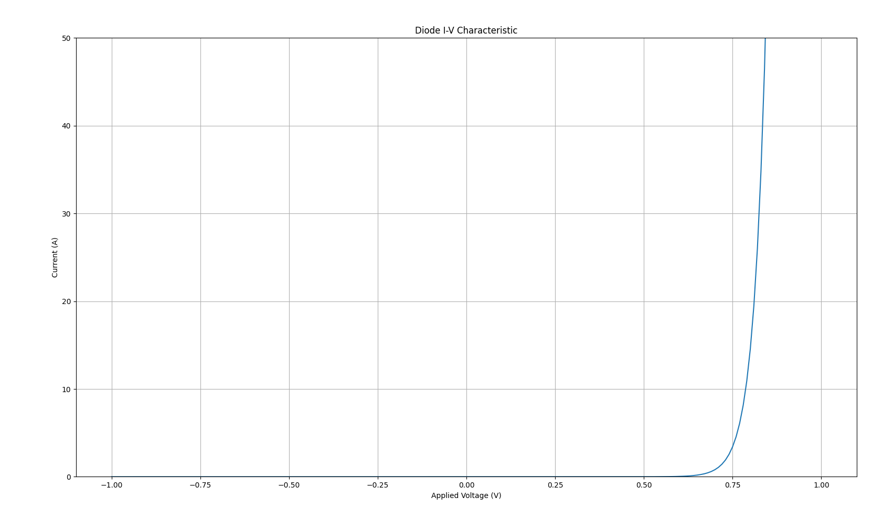
Figure 1: I-V Sweep for diode
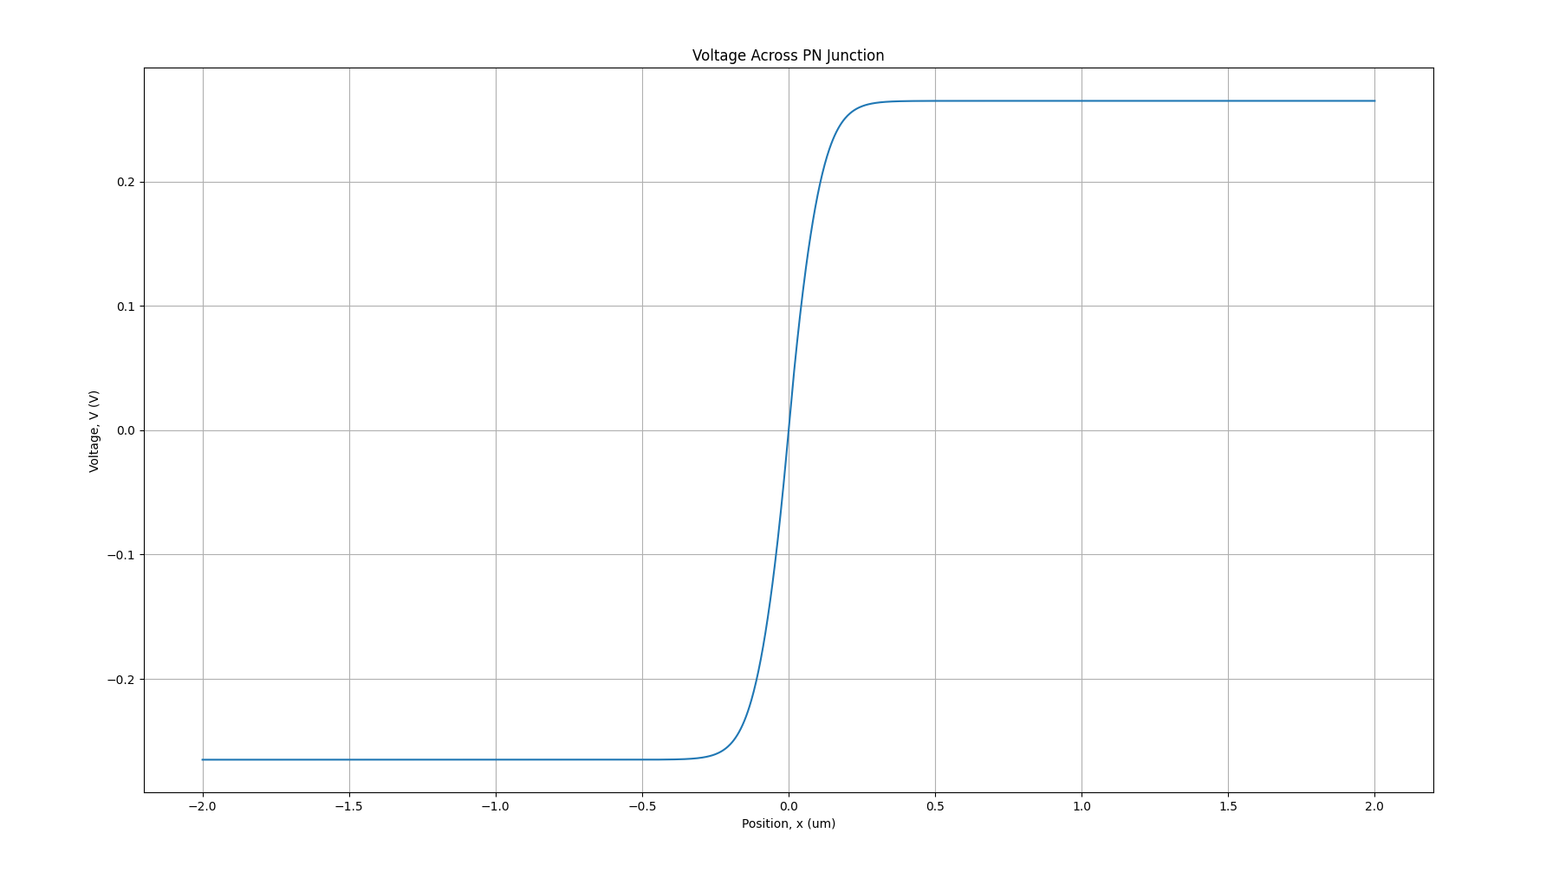Figure 2: Voltage throughout diode
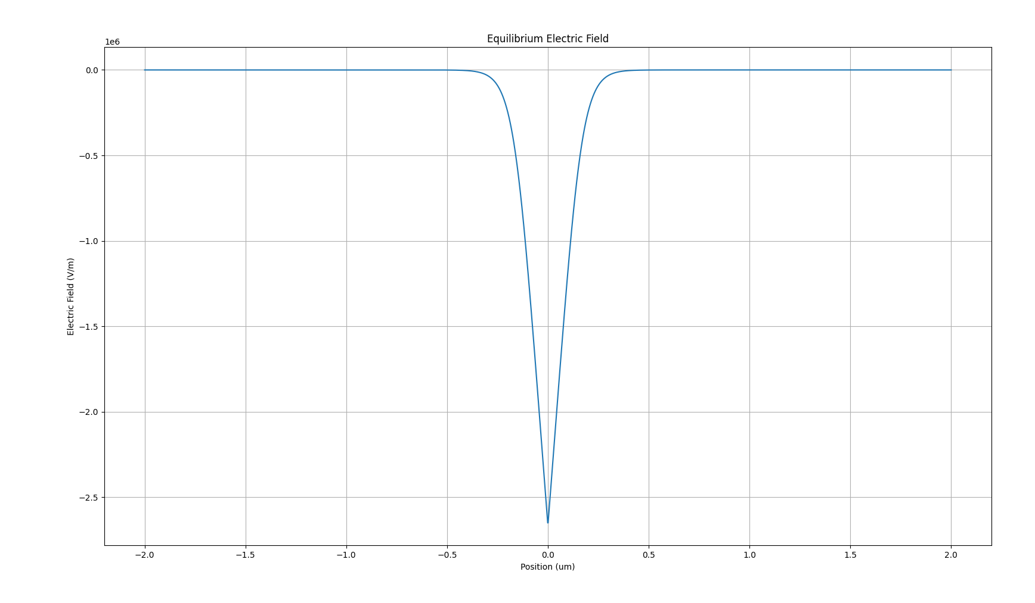
Figure 3: Electric Field throughout diode
5 Development Challenges
5.1 Residual Error
Symptom: The residual stopped decreasing partway through the iteration, plateauing at a small value regardless of further iterations
Diagnosis: Printing the residual at each iteration showed it decreasing smoothly at first, then freezing at a fixed value for the rest of the convergence until max iterations was reached.
Cause: The equation was being solved in SI units and so terms combined terms differing by many orders of magnitude. This amplified small floating-point errors to the point where they were impacting the residual greatly.
Fix: The system was nondimensionalised (Sectio 3.4) to remove the large factors responsible for amplifying the rounding error.
5.2 Uniform Quasi-Fermi shift
Symptom: Attempting to represent an applied bias by shifting the quasi-fermi levels by a constant amount across the whole pn junction, rather than a change local to the junction.
Diagnosis: A uniform shift in the quasi-fermi levels assumes that carrier concentration is constant throughout the device instead of splitting at the junction where they must decay back down to match each other as you move to the edges. If the quasi-fermi levels do not decay, it is assumed that the injected minority carriers do not recombine and so the semiconductor would be storing a massive amount of charge. To represent this decay correctly the minority carrier continuity equation has to be solved, which this model does not include.
Resolution: Instead of approximating this effect, it was taken out of Version 1 and instead expressed via Shockley’s current model (Section 2.5).

6. Limitations and Further Work
The main limitation of Version 1 is that the equilibrium carrier statistics (Section 2.2) are only valid under no bias, so the model cannot simulate current flow through the junction itself, only the current at the terminals via the separate Shockley equation (Section 2.5). Extending the model to do this would require solving the minority carrier continuity equation alongside Poisson's equation, allowing the quasi-Fermi levels to vary correctly with position rather than being fixed.
The model is also restricted to a step junction on a uniform grid (Section 2.4, Section 3.5), meaning grid resolution must be increased manually at higher doping concentrations, and a graded junction profile is not currently supported.
Future versions could address these by implementing the continuity equations for a full drift/diffusion model, extending the doping profile to allow graded junctions, and moving to an adaptive, non uniform grid to resolve the depletion region efficiently across a wider range of doping concentrations without needing to increase resolution uniformly across the whole device.

